Herrera, Mark Daniel L.
BSIT 2-F1

EXERCISE 3.

- Select * From employee_data where l_name like “P%”;
- Select f_name, l_name From employee_data where title = ‘Marketing Division’;
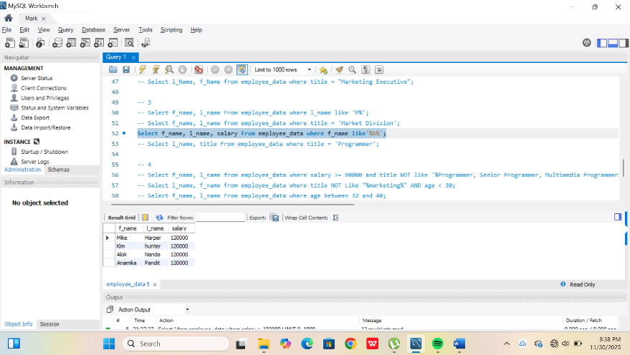

- Select l_name From employee_data where title = ‘Programmer’

